Appendix A. Sample report Layouts

Maestro Reservation Interface

This appendix contains sample layouts for the Maestro Reservation Interface reports. The purpose of these layouts is to show the report implementation and formatting. Because of the limited data available in the development environment, many of the sample reports show data which does not completely match the specifications. In particular, run dates and other dates shown in the sample layouts may not reflect constraints and limitations described in the specification. The delivered reports will be implemented as per the specifications in the main body of this document.

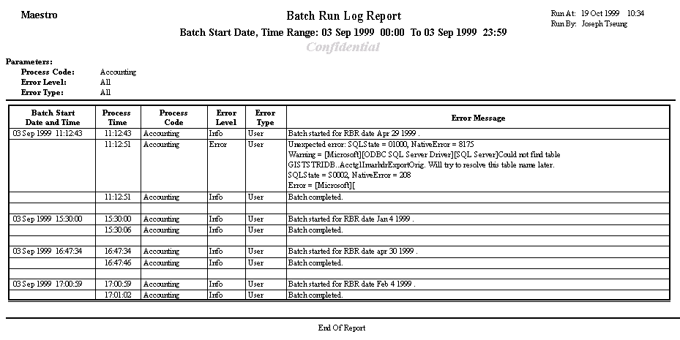Batch Run Log Report

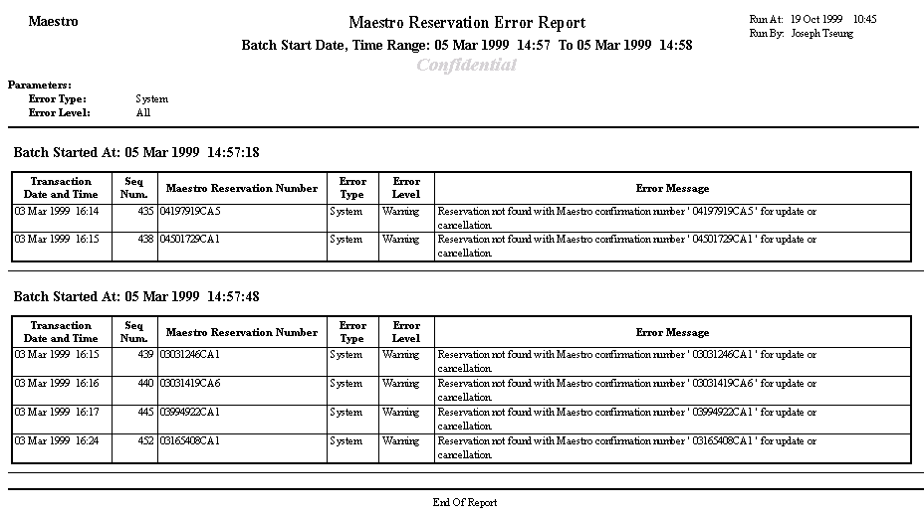Maestro Reservation Error Report

